Registration Guide
- Register as new user (the yellow tag below)
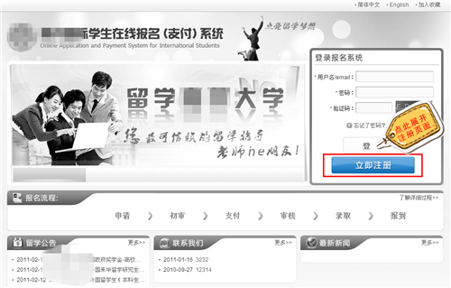
- 完成注册项填写，同意注册协议后点击注册按钮完成注册操作。
Fill in the required items, tick “agree the terms”(the first yellow tag), and press “finish and register”(the second yellow tag)
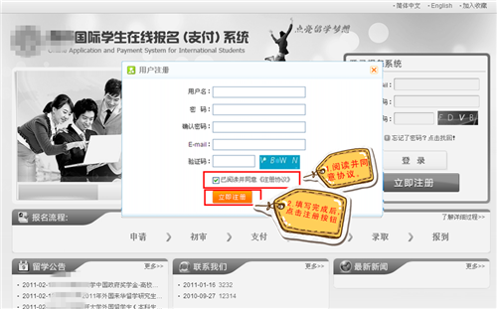
- 根据提示进入注册邮箱，接收激活邮件并点击激活按钮使注册账户生效。
Enter your email box, and activate the registration.(the email has English)
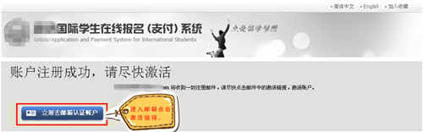
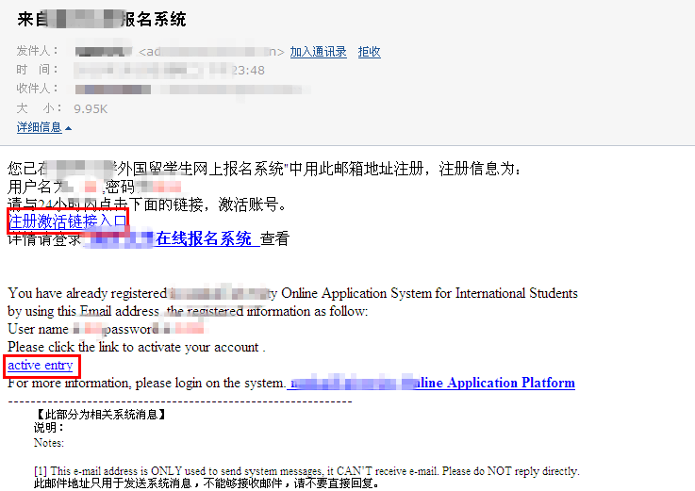
- 进入报名系统填写个人信息，并注意查收系统收到的通知信息。
Enter into the application system and fill in the items.
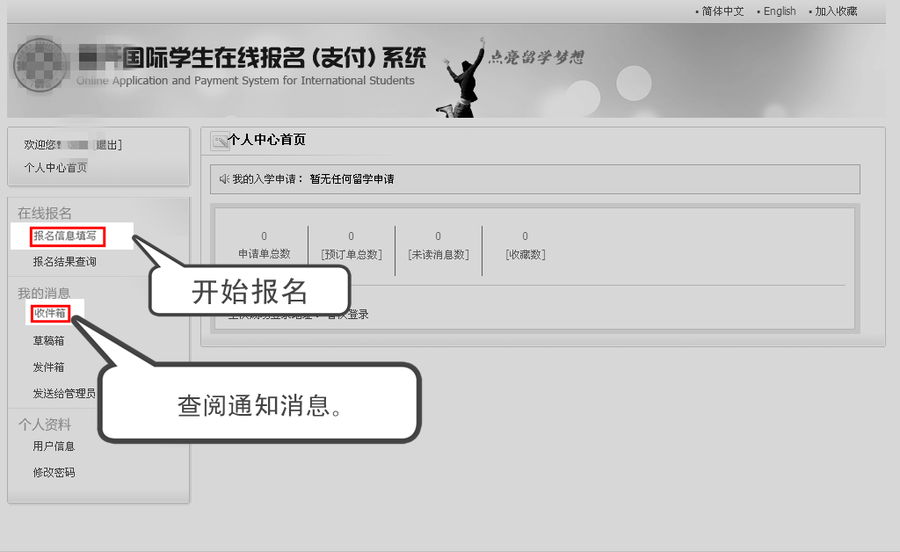

- 可多次进入系统完善报名信息，核实申请单所处报名流程状态。
You may re-enter into the system to change your information and check the status.
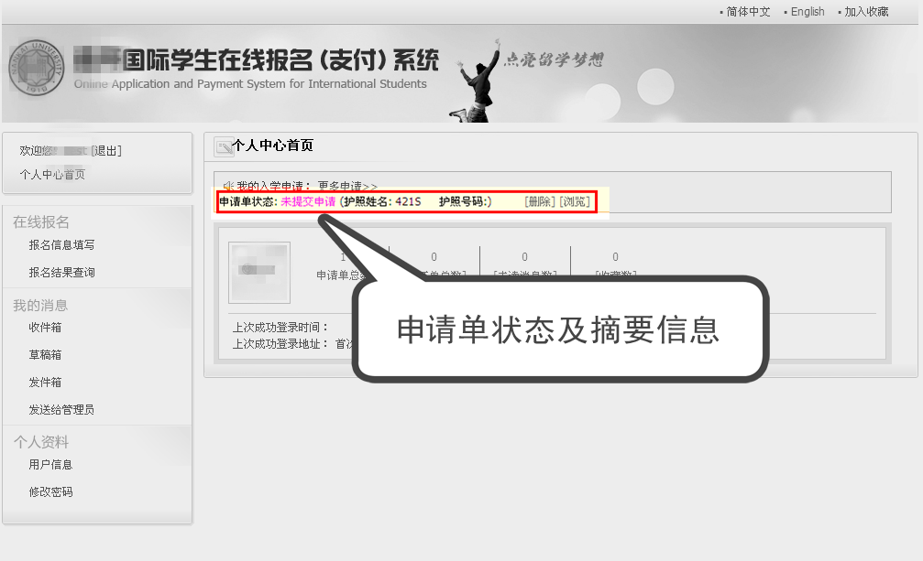
- 完成申请单填写信息后，按照指示提交申请单，等待校方初审通过。
When you finish the application, submit and wait for review.
